Name=anok

Batch =125

[Gmail=anokay14@gmail.com](mailto:Gmail=anokay14@gmail.com)

**Today topic: How to create life cycle**

**1] Create bucket:**

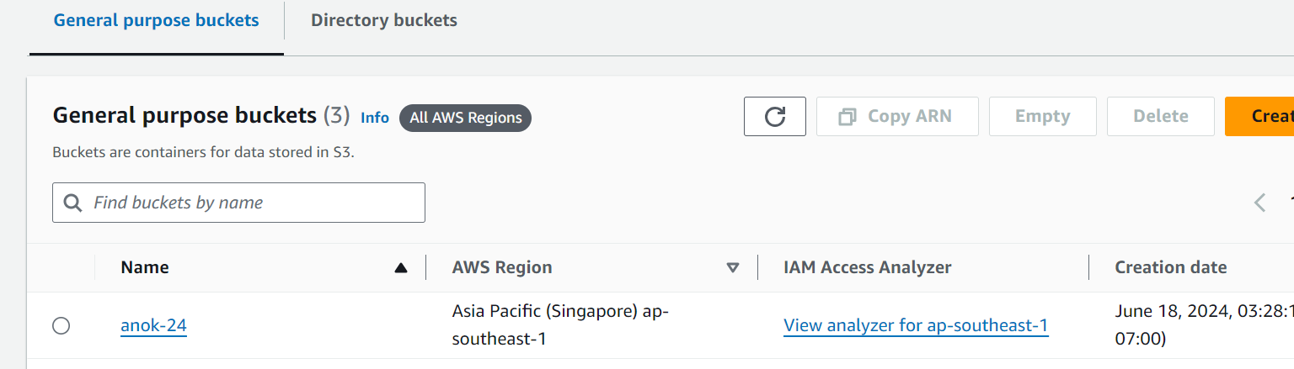

**2] upload file:**

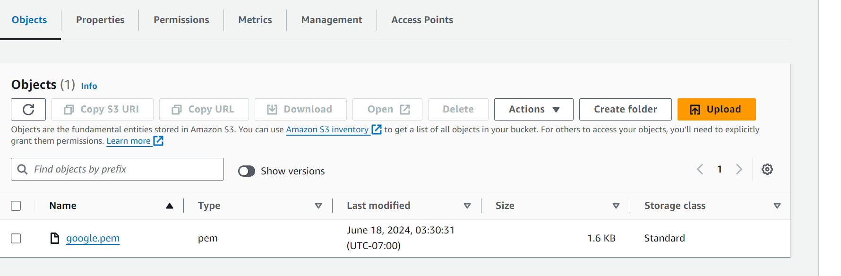

**3]create life cycle:**

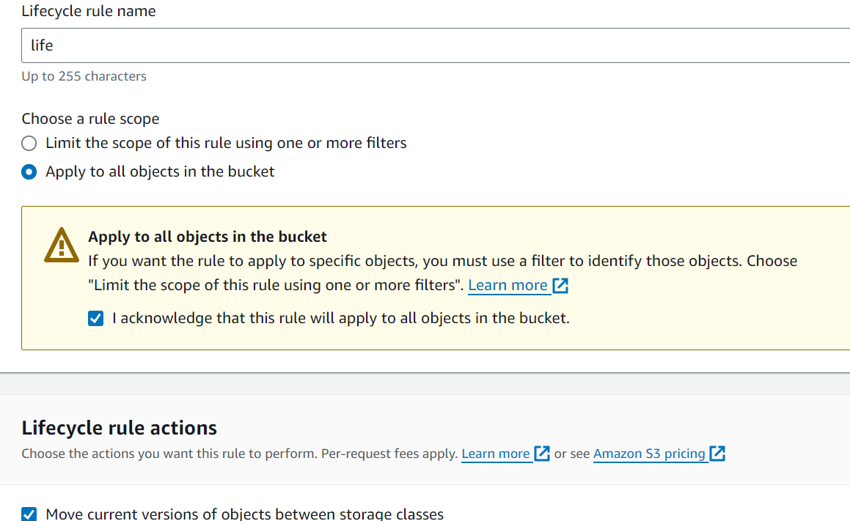

**4]add the storage clases:**

